**Binary Tree Level Order Traversal**

<https://leetcode.com/problems/binary-tree-level-order-traversal/>

Given the root of a binary tree, return *the level order traversal of its nodes' values*. (i.e., from left to right, level by level).

**Example 1:**

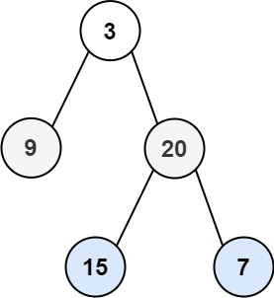

**Input:** root = [3,9,20,null,null,15,7]

**Output:** [[3],[9,20],[15,7]]

**Example 2:**

**Input:** root = [1]

**Output:** [[1]]

**Example 3:**

**Input:** root = []

**Output:** []

**Constraints:**

* The number of nodes in the tree is in the range [0, 2000].
* -1000 <= Node.val <= 1000